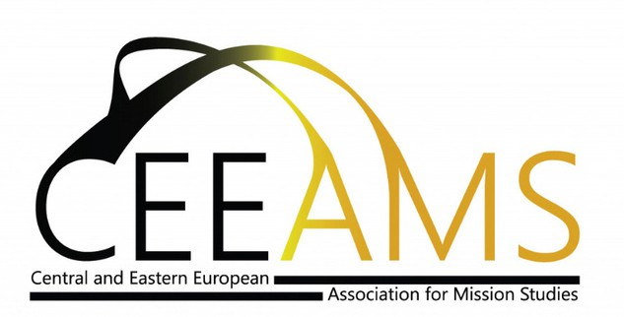CEEAMS 2025 ANNUAL CONFERENCE

Osijek, 14-17 February

“We Believe in… the Lord, the Giver of Life”: Polycentric Mission from and beyond Nicea

(Draft subject to change)

|  |  |  |  |
| --- | --- | --- | --- |
| **Friday (14 February 2025)** | **Saturday (15 February 2025)** | **Sunday (16 February 2025)** | **Monday (17 February 2025)** |
| 15:00-16:45  Registration | 09:00-09:30  Bible exposure | 09:00-13:00  Sunday Services/Liturgy/Mass in different communities in Osijek | 09:00-09:30  Bible exposure |
| 17:00 -17:30  Opening of the conference (Dalibor Kraljik, Dorottya Nagy) | 09:30- 10:30  Keynote  **Martine Audeoud**  Polycentric missions: Reflections and lesson learned from African Independent Churches | 13:00  Lunch | 09:30  Keynote  **Paul Siladi**  Embodied Faith: The Nicene Creed and the Theology of Deeds  Response: **John Flett** |
| 17:30-18:30  Keynote  **JNJ “Klippies” Kritzinger**  Power in mission – mission in power: transformative encounters in the shadow of Nicea” | 10:30-11:00  Coffee break  Keynote  11.00-12:00  **Cathy Ross**  The diversity we need”: decolonising mission education through building diverse and just relationships | 14:30 -16:00  Parallel paper sessions  Session 4. **XXXXX**  Session 5. **YYYYY** | 11:00  Coffee break |
| 18:30  Dinner | 12:00  Writing seminar | 16:00: 16:30  Coffee break  16:30-17:30  **Wojciech Kluj**  The linguistic angle on the Nicaea Council and Creed in relation to the contemporary missionary concept of inculturation  17:30  News within and from our network | 11:30  Parallel paper sessions  Session 6.**XXX**  Session 7. **YYYY** |
| 19:45 – 20:45  Keynote  **Martha Frederiks:**  Studying Christianity in the 21st century: Some reflections | 13:00  Lunch | 18:00  Dinner | 13:00  Closing |
|  | 14:00 – 15:30  Parallel paper sessions  Session 1. **XXXX**  Session 2. **YYYY**  Session 3. **ZZZZZ** | 19:00  Book panel with **Usha Reifsnider**  and  New books, new research, new practices from our network | 13:30  Lunch |
|  | 15:30-16:00  Coffee break  **16:00-18:00**  **CEEAMS General Assembly** |  | 14:30  Departure |
|  | 18:00  Dinner |  |  |
|  | 19:00  Departure to the Concert  Concert starts at 20:00 |  |  |